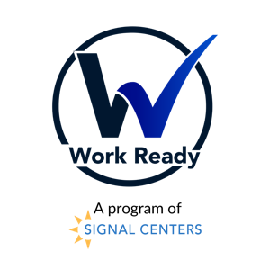

Please email this referral to our Work Ready email at workready@signalcenters.org.

For questions, please call Joyce Jackson or Selah Melvin at (423) 994-3192.

Work Ready Referral
Date:

REFERRING AGENCY INFORMATION
Name of Referring Staff: | Agency Name:
Work Phone (ext. if applicable): | Address:
Email Address:
APPLICANT INFORMATION
Name:
Address:
Home Phone: __________________________  Mobile Phone: _________________________ | Best time to reach:  - Morning  - Noon
E-mail: | Gender:
Date of Birth: | Race:
Are you a citizen of the United States?  Yes No | Did you receive a high school diploma, GED or HiSet?  Yes No
Do you have at least one child 18 yrs. old or younger (or 19 yrs. and still in high school)?  Yes No | Do you live in Tennessee?  Yes No
Have you ever been justice involved?  Yes No | If yes, please explain:
RESOURCE INFORMATION
Are you receiving any of the following services: Please circle all that apply.

TennCare Public Housing
SNAP/Food Stamps Housing Choice Voucher/Section 8
Unemployed Free or Reduced Lunch

AVAILABLITY
Are you available for up to 15 hours of paid internship (9 AM- 12 PM)?

Yes No
What day(s) are you available to intern? Please circle all that apply.

Monday Tuesday Wednesday Thursday Friday
Are you available for college course work three days each week (1 PM- 3PM)?

Yes No

FOR WORK READY STAFF ONLY
Case Manager Name: | Date Received:
Eligible for WRP: Yes/No | If not, were additional services provided? Yes/No
Case Manager Signature: | Date Completed:

